For this Project we need 3 VMs - Kali as attacker machine

2 Ubuntu machines - 1 as a Honeypot

1 as an Actual server machine

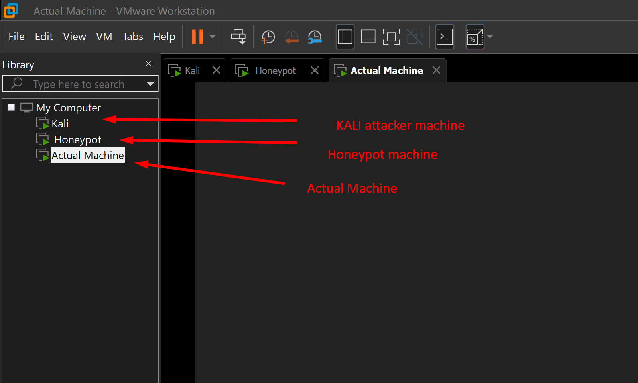

First we need to **Install OpenSSH in both the machines - Honeypot and Actual machine**

sudo apt install openssh-server -y

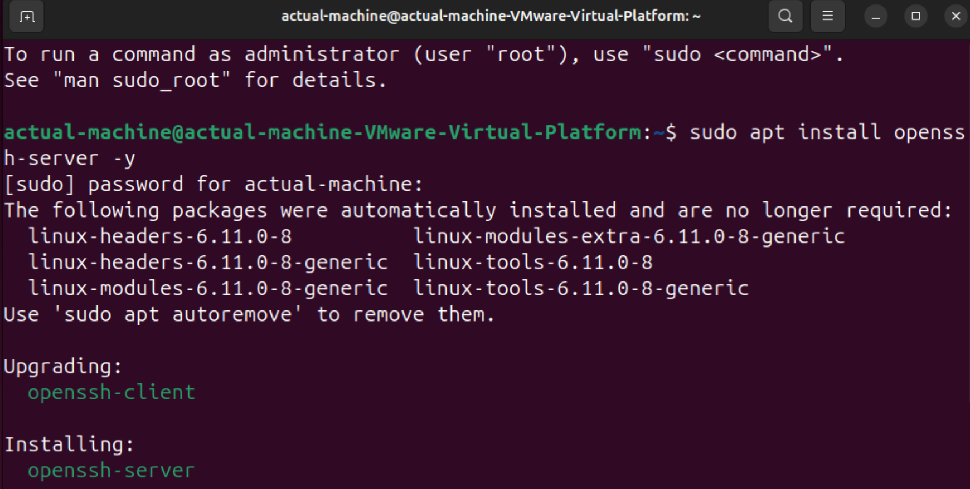

Now we have to check the status of the ssh - **sudo systemctl status ssh**

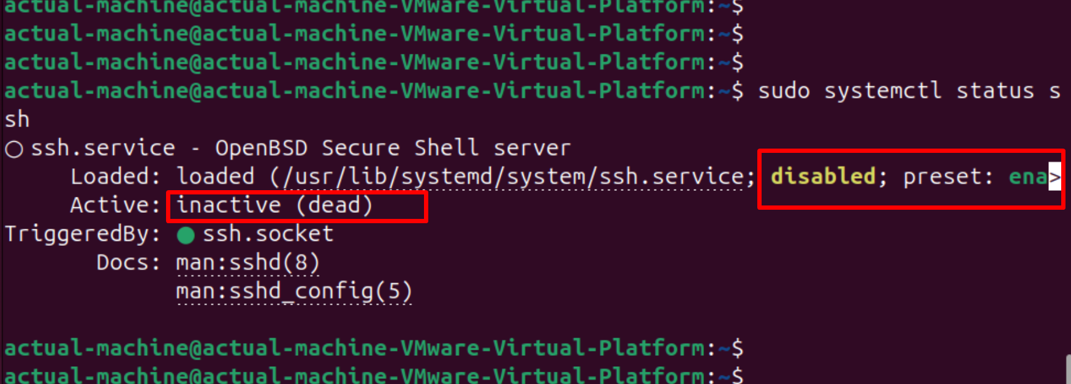

Here we need to start the ssh service -  **sudo systemctl start ssh**

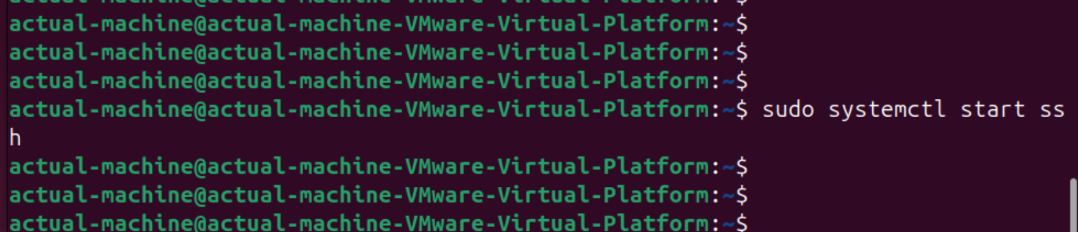

Now we need to enable the ssh service using command - **sudo systemctl enable ssh**

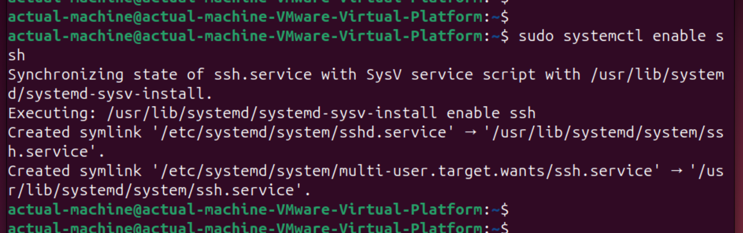

Now we will have to restart the service to refresh service’s state - **sudo systemctl restart ssh**

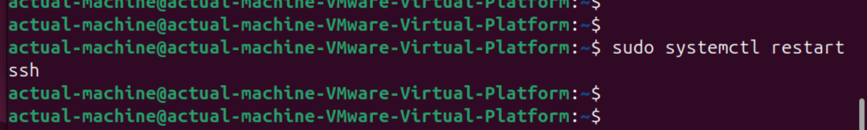

Now again we have to check the status of the ssh - **sudo systemctl status ssh**

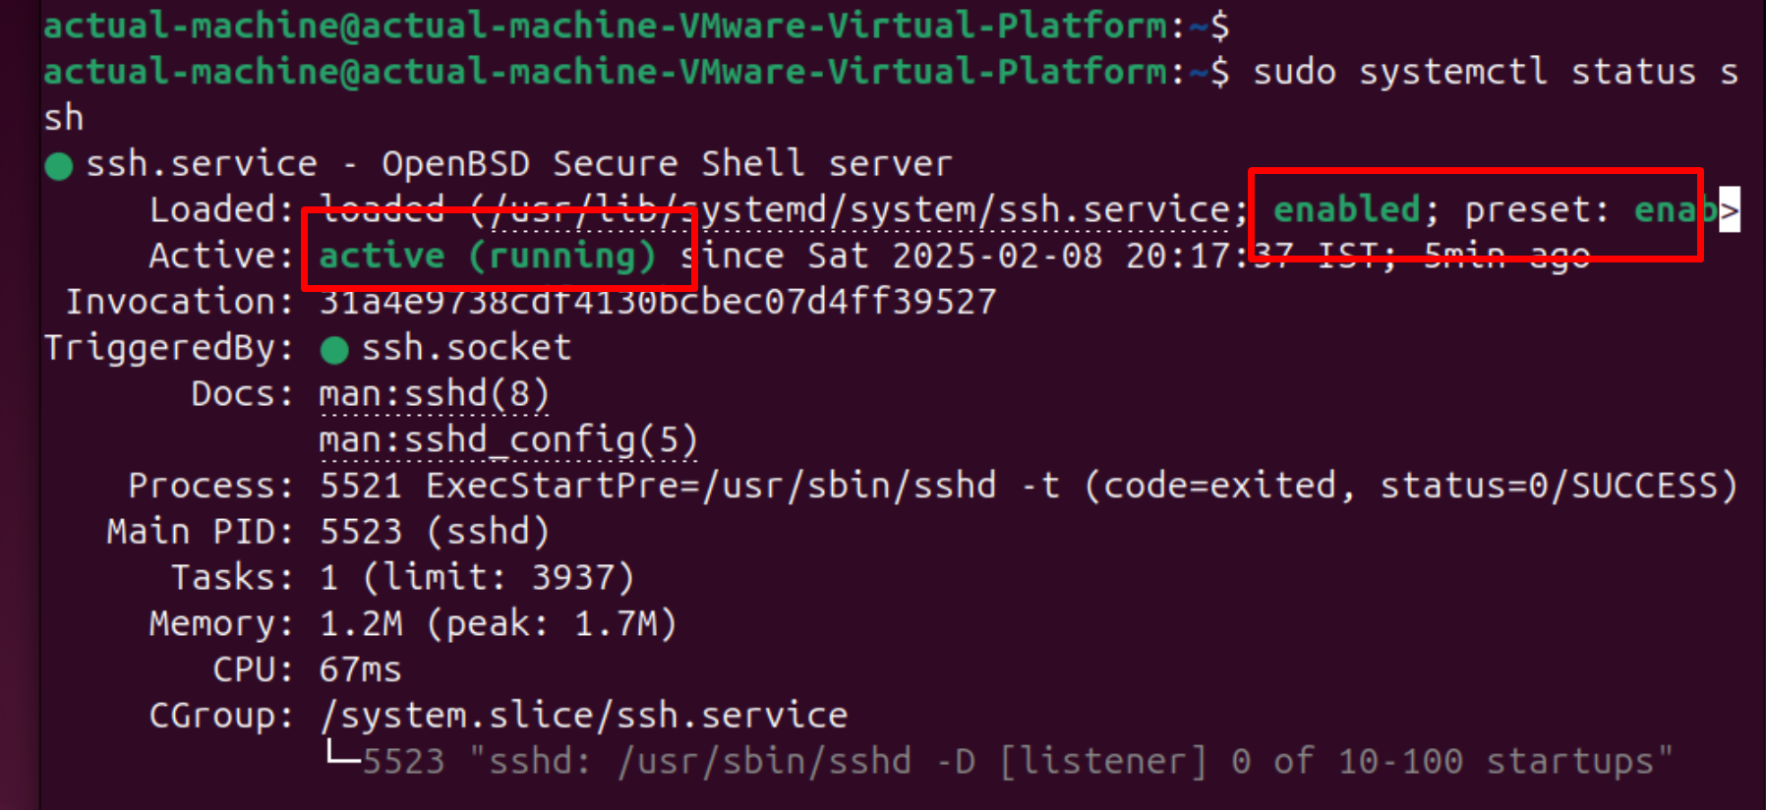

We can see the status is **active** and **running.** We will perform the same operations in our

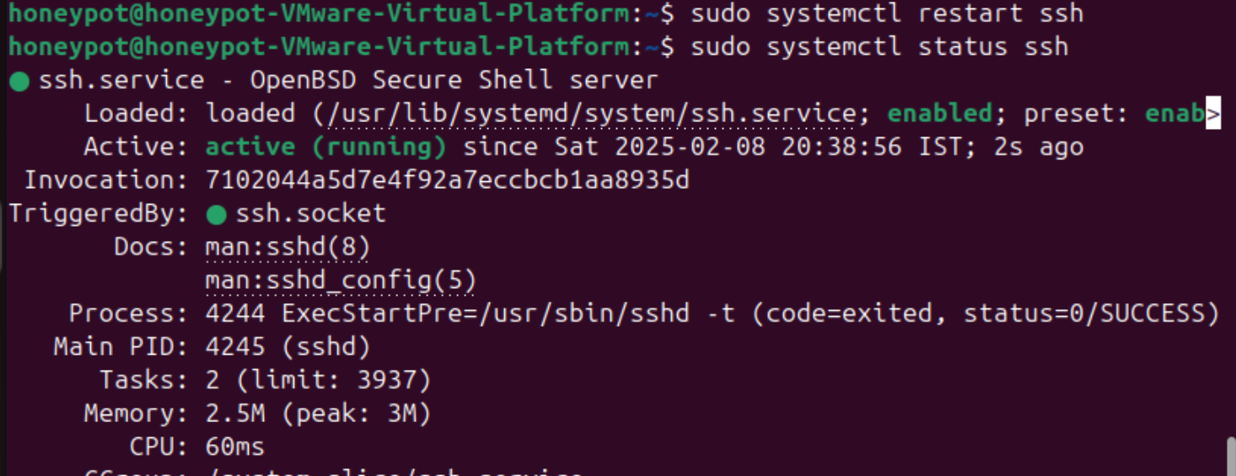

Now we need to start the **HTTP** service on both the machines **Honeypot** as well as **Actual server machine**

For running HTTP service first we need to install HTTPweb application service

For that we need to run the command - **sudo apt install apache2 -y**

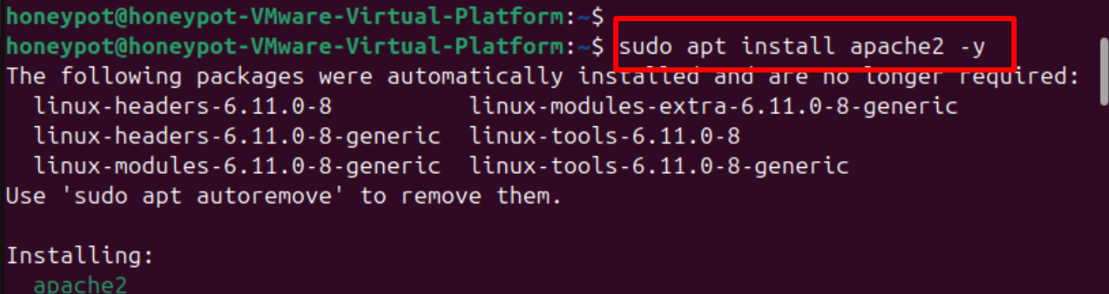

Now we need to check the status of the apache2 service - **sudo systemctl status apache2**

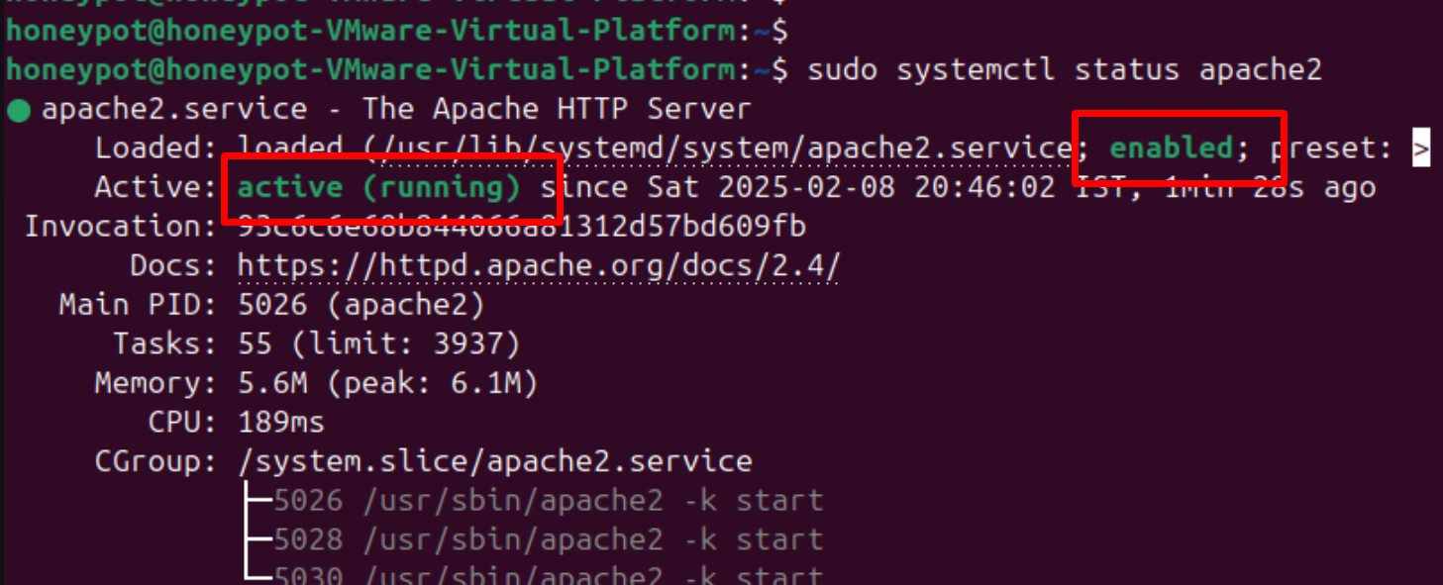

Here we see the status is **active** and **running**

Now we will try to install SMB service in both the VMs

First we need to use this command - **sudo apt install -y samba** to install samba server in our Ubuntu VM

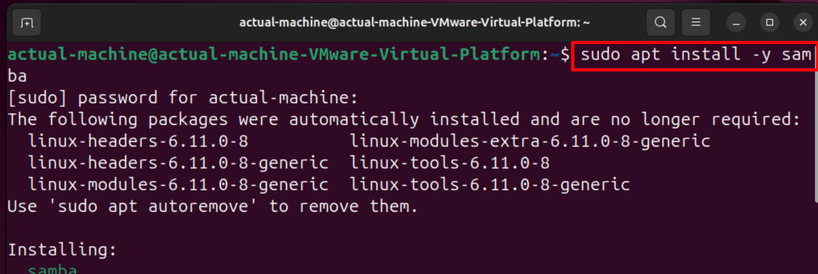

Creating secure SMB share

**sudo mkdir -p /srv/samba/secure**

**sudo chmod 770 /srv/samba/secure**

**sudo chown nobody:nogroup /srv/samba/secure**

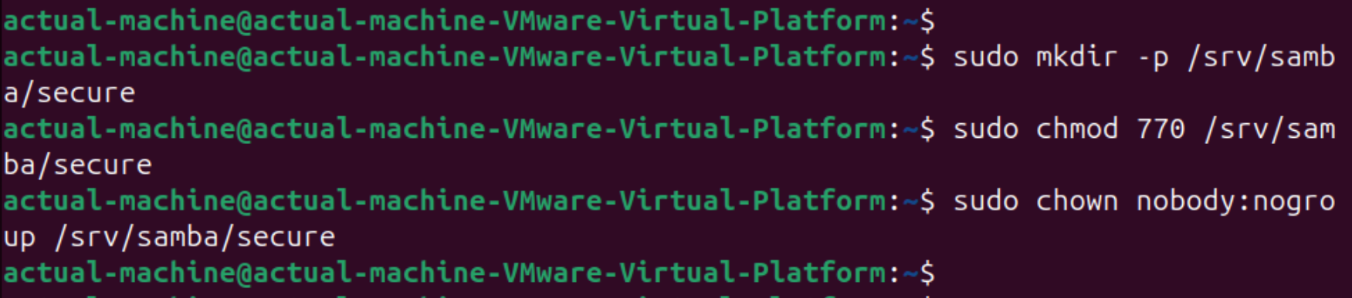

Configuring secure SMB in Actual Ubuntu server

**sudo vim /etc/samba/smb.conf**

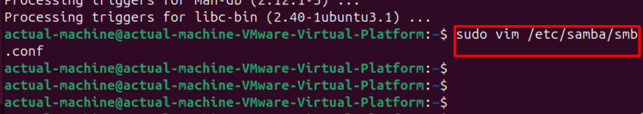

Now we need to add few configurations at the bottom

**[SecureShare]**

**path = /srv/samba/secure**

**browsable = yes**

**read only = no**

**valid users = @smbusers**

**force user = nobody**

**create mask = 0640**

**directory mask = 0750**

**guest ok = no**

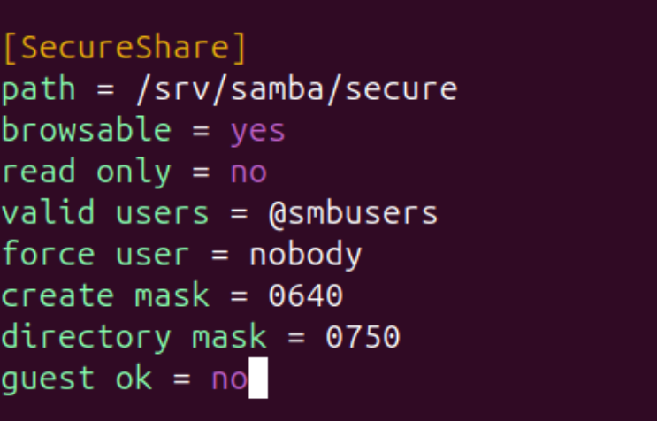

Now we need to create a SMB user

**sudo groupadd smbusers**

**sudo useradd -M -s /sbin/nologin smbuser**

**sudo usermod -aG smbusers smbuser**

**sudo smbpasswd -a smbuser**

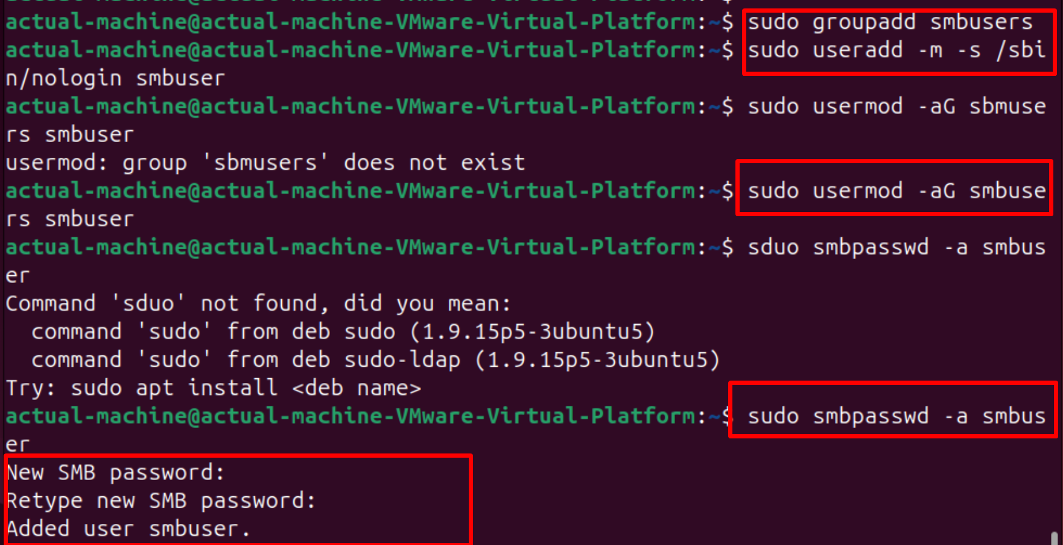

Harden SMB configuration - **/etc/samba/smb.conf** disable **SMBv1** and do the following changes

**server min protocol = SMB2**

**server max protocol = SMB3**

**map to guest = never**

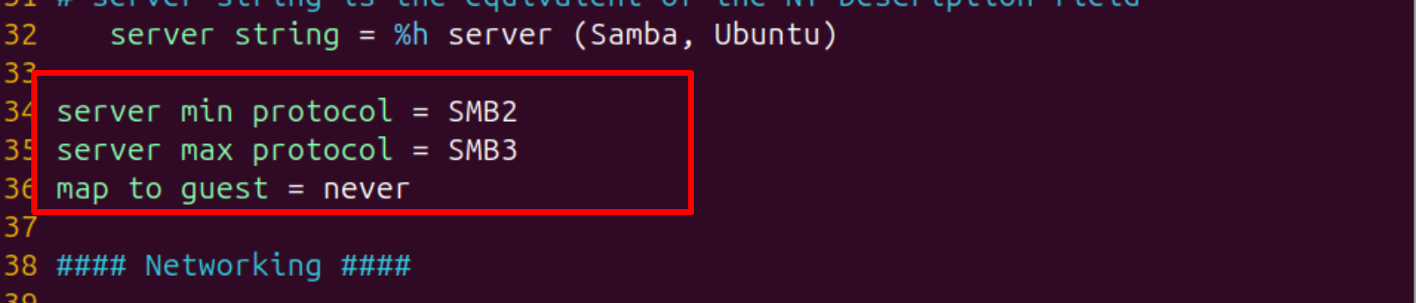

Then save and exit after changing the configuration

Then restart the SMB service - **sudo systemctl restart smbd**

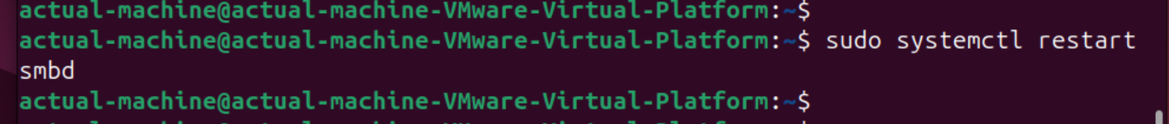

Now we need to secure this with the firewall -

**sudo ufw allow 139,445/tcp**

**sudo systemctl restart ufw**

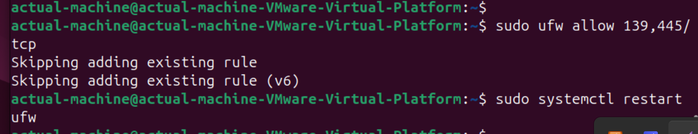

Now let’s do the SMB configuration in the **Honeypot machine**

First we need to install samba - **sudo apt install -y samba**

Then creating the vulnerable SMB share -

**sudo mkdir -p /srv/samba/public**

**sudo chmod 777 /srv/samba/public**

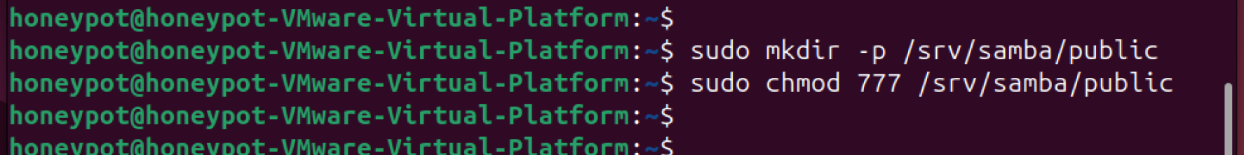

Now we need to configure the SMB for vulnerability - **sudo vim /etc/samba/smb.conf**

Then we need to add this configuration at the bottom :

**[Public]**

**path = /srv/samba/public**

**browsable = yes**

**read only = no**

**guest ok = yes**

**force user = nobody**

**create mask = 0777**

**directory mask = 0777**

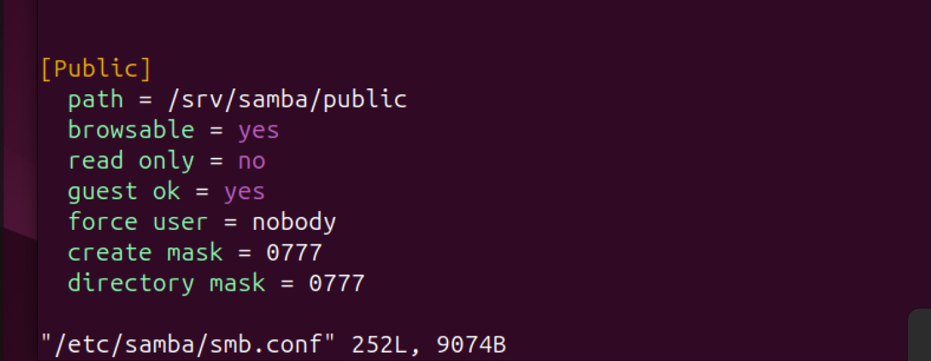

Enable SMBv1 deliberately insecure - add at the end of the Global settings

**server min protocol = NT1**

**guest ok = yes**

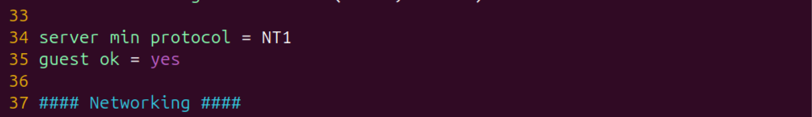

Now restart SMB - **sudo systemctl restart smbd**

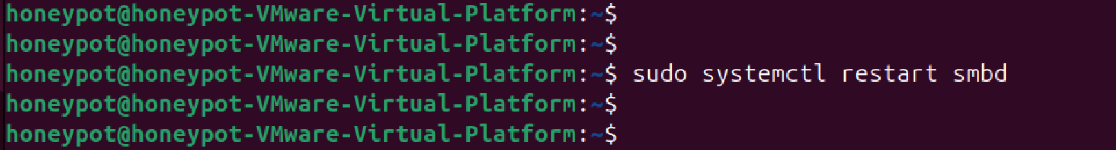

Configure firewall rule to expose the Honeypot and allow the traffic

**sudo ufw allow 139,445/tcp**

**sudo systemctl restart ufw**

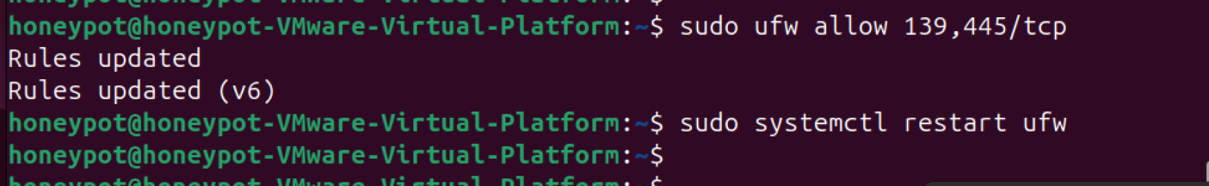

Now we will again configure another service FTP, now need to install **vsftpd** service

First we will configure the actual server machine

**sudo apt install -y vsftpd**

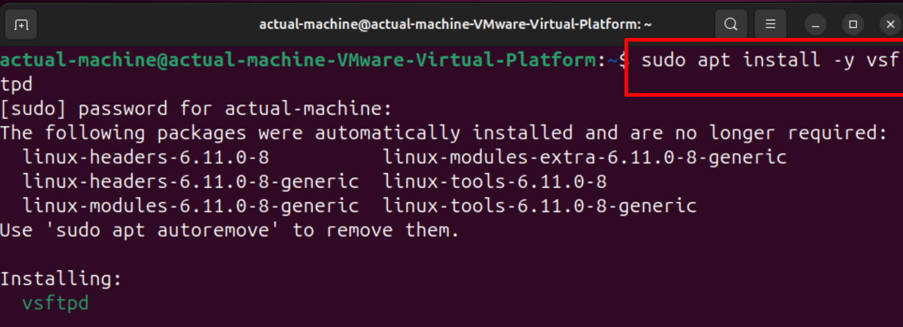

Create a Secure FTP Directory -

**sudo mkdir -p /srv/ftp_secure**

**sudo chmod 750 /srv/ftp_secure**

**sudo chown ftp:ftp /srv/ftp_secure**

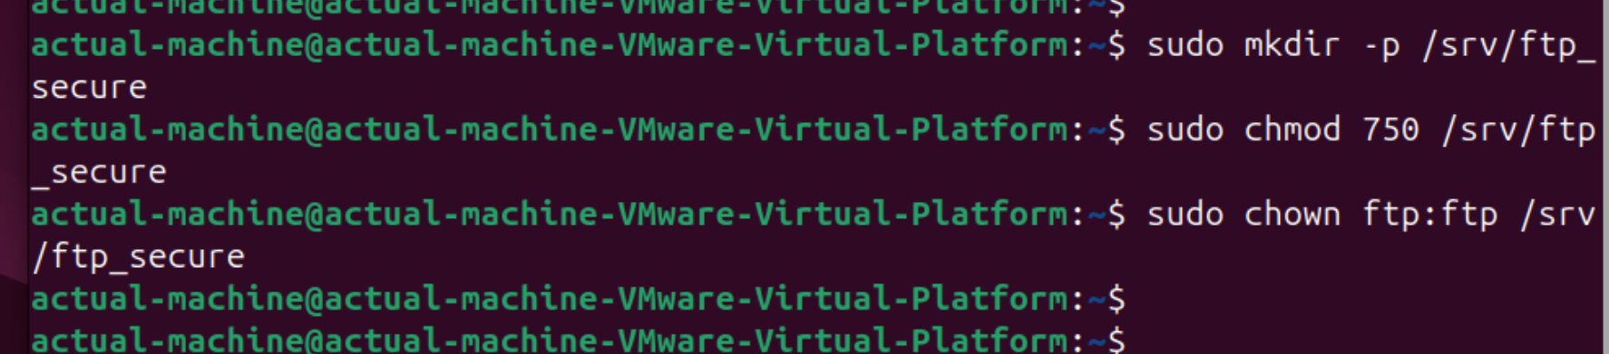

Configure Secure FTP - **sudo vim /etc/vsftpd.conf**

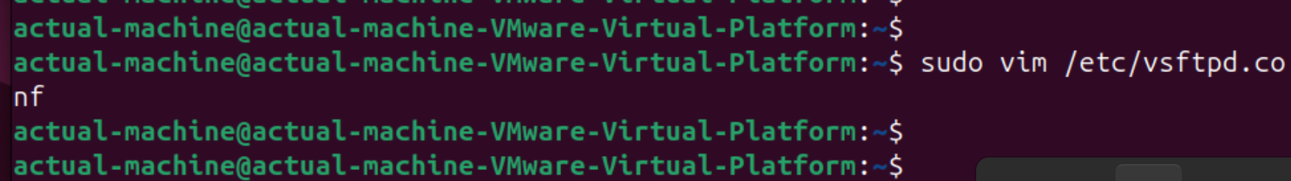

Then add these lines at the end

**listen=YES**

**listen_ipv6=NO**

**anonymous_enable=NO**

**local_enable=YES**

**write_enable=YES**

**chroot_local_user=YES**

**allow_writeable_chroot=NO**

**ssl_enable=YES**

**force_local_logins_ssl=YES**

**force_local_data_ssl=YES**

**pasv_min_port=40000**

**pasv_max_port=50000**

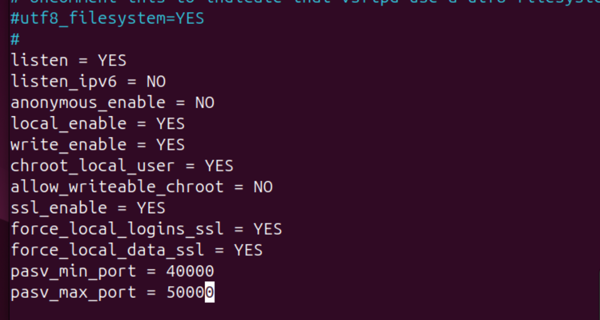

### **Secure FTP with User and TLS**

Create an FTP user:

**sudo useradd -m -d /srv/ftp_secure -s /sbin/nologin ftpuser**

**sudo passwd ftpuser**

**sudo chown ftpuser:ftpuser /srv/ftp_secure**

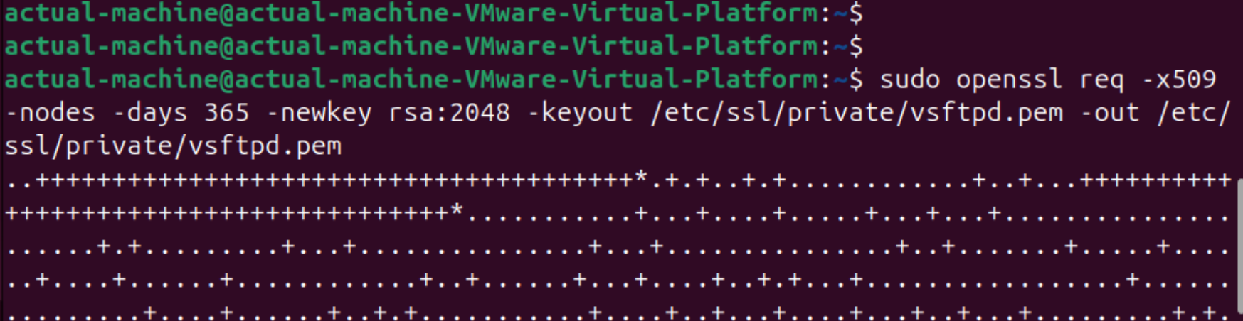

Now we need to generate certificate -

**sudo openssl req -x509 -nodes -days 365 -newkey rsa:2048 -keyout /etc/ssl/private/vsftpd.pem -out /etc/ssl/private/vsftpd.pem**

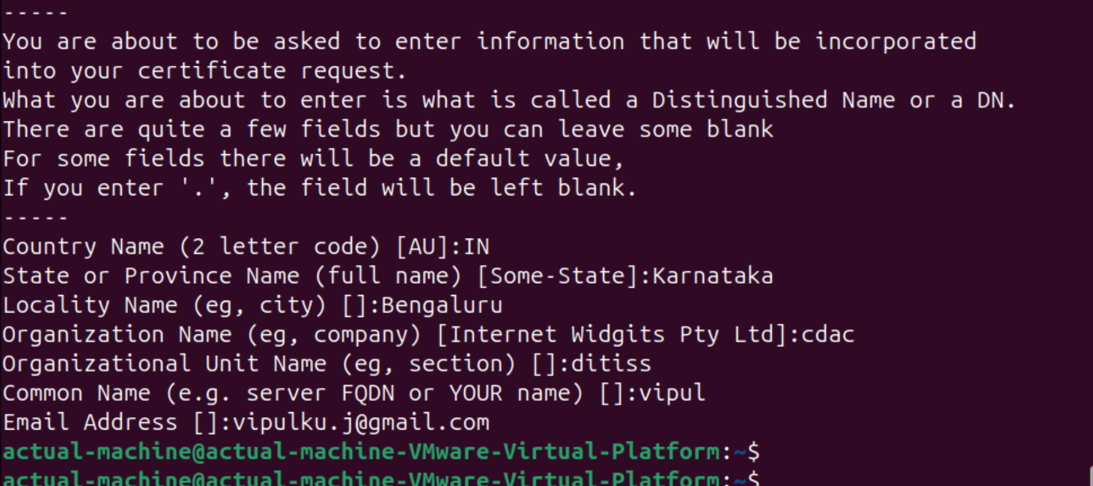

Edit /etc/vsftpd.conf and add:

**rsa_cert_file=/etc/ssl/private/vsftpd.pem**

**rsa_private_key_file=/etc/ssl/private/vsftpd.pem**

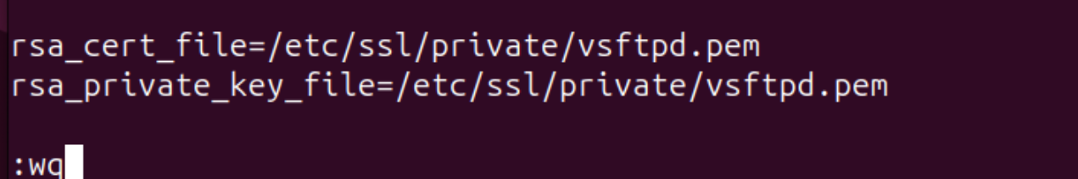

Now restart vsftpd service - **sudo systemctl restart vsftpd**

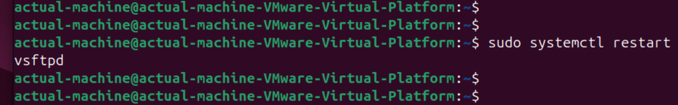

Allow FTP Through Firewall

**sudo ufw allow 21/tcp**

**sudo ufw allow 40000:50000/tcp**

**sudo systemctl restart ufw**

## **Honeypot Machine (Vulnerable FTP Server)**

### Install vsftpd - **sudo apt install -y vsftpd**

Then create a vulnerable directory -

**sudo mkdir -p /srv/ftp_vulnerable**

**sudo chmod 777 /srv/ftp_vulnerable**

**sudo chown nobody:nogroup /srv/ftp_vulnerable**

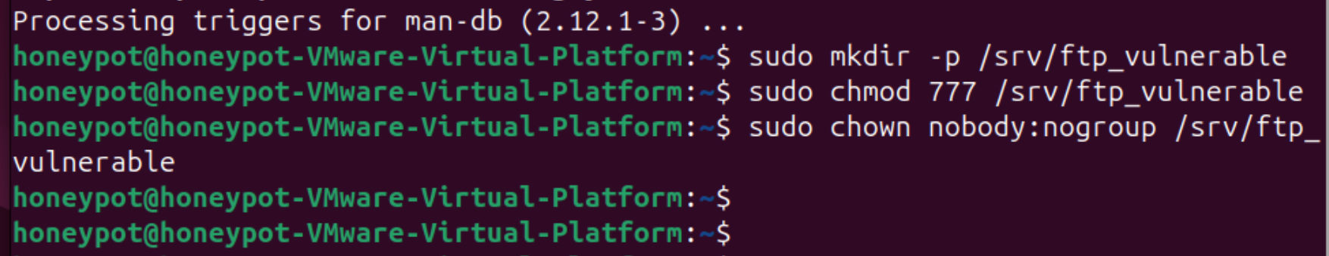

Now we need to configure vulnerable FTP - **sudo vim /etc/vsftpd.conf**

Then do the following changes in the configuration files

**listen=YES**

**listen_ipv6=NO**

**anonymous_enable=YES**

**local_enable=YES**

**write_enable=YES**

**chroot_local_user=NO**

**allow_writeable_chroot=YES**

**ssl_enable=NO**

**pasv_min_port=40000**

**pasv_max_port=50000**

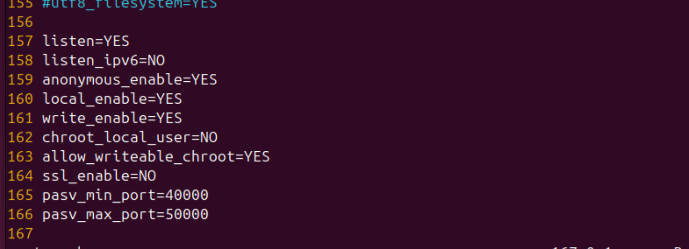

Now we need to restart the FTP service - **sudo systemctl restart vsftpd**

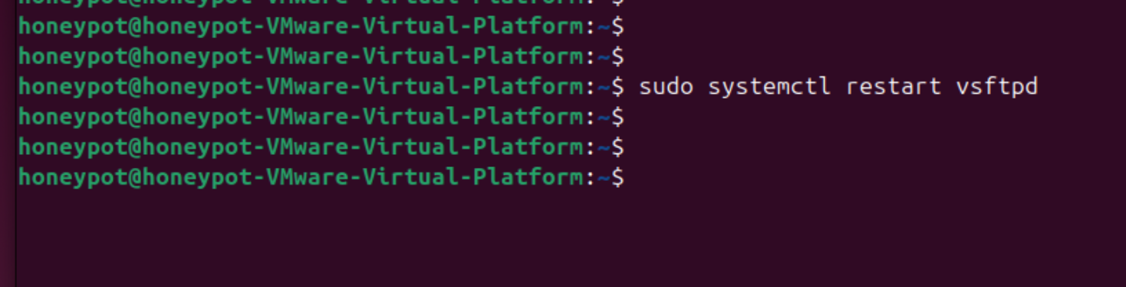

Allow FTP traffic -

**sudo ufw allow 21/tcp**

**sudo ufw allow 40000:50000/tcp**

**sudo systemctl restart ufw**

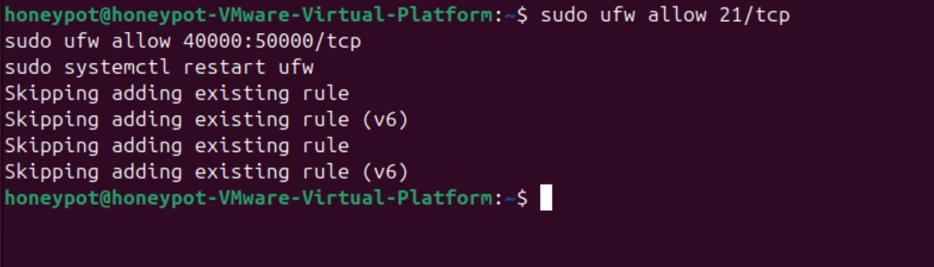

Then monitor FTP logs when the attacker attacks - **tail -f /var/log/vsftpd.log**

Now we need to configure firewall rules first we need to configure the **Actual server machine**

Enable UFW and Firewall rules -

**sudo ufw default deny incoming**

**sudo ufw default allow outgoing**

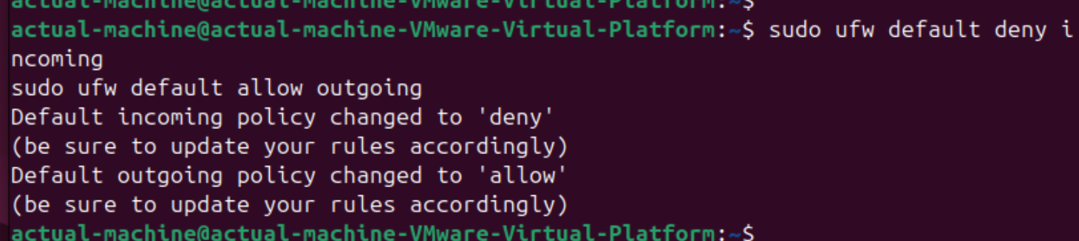

Allow Essential Services like - SSH, HTTP, SMB and FTP

**sudo ufw allow 22/tcp SSH (for remote access)**

**sudo ufw allow 80/tcp HTTP (if needed)**

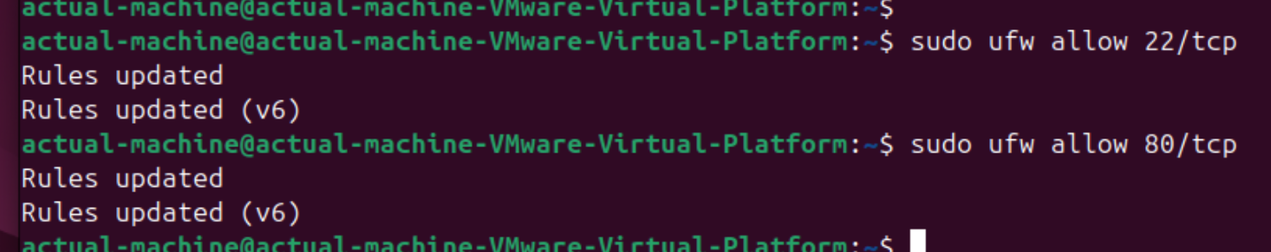

Allow Specific Services (SMB, FTP) -

**sudo ufw allow from 192.168.41.0/24 to any port 139,445 proto tcp # SMB**

**sudo ufw allow from 192.168.41.0/24 to any port 21 proto tcp # FTP**

**sudo ufw allow from 192.168.41.0/24 to any port 40000:50000 proto tcp # Passive FTP**

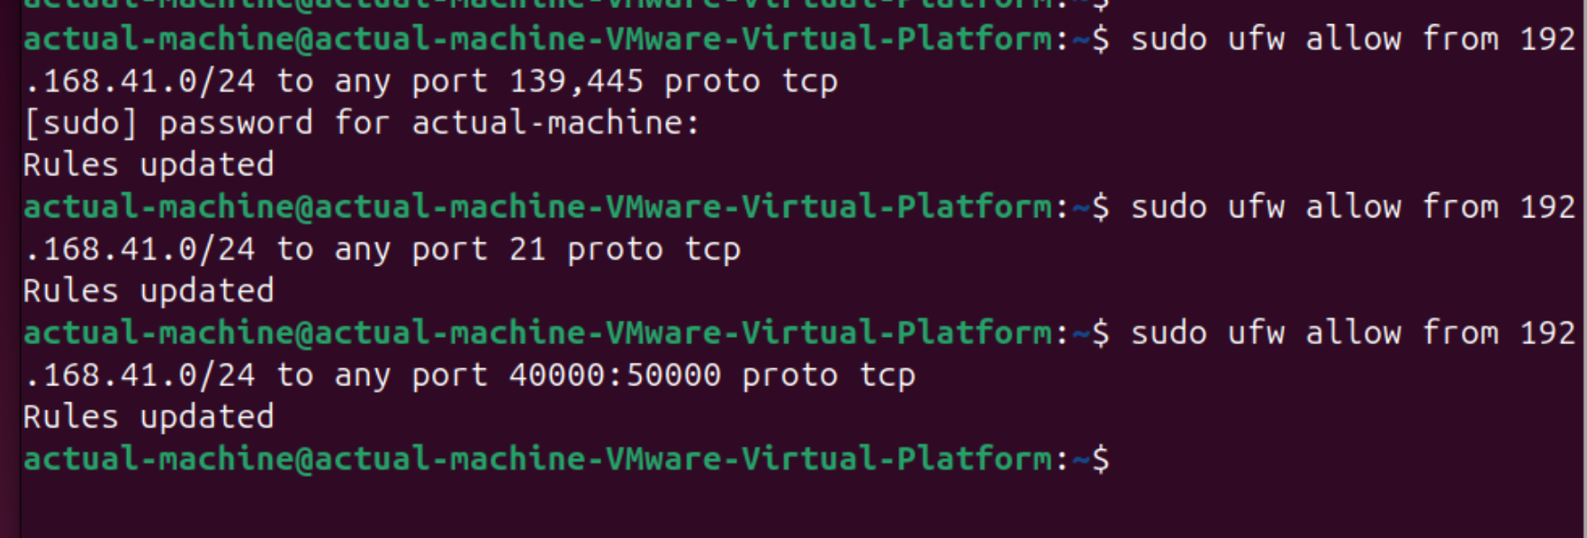

Enable Logging & Restart the Firewall

**sudo ufw logging on**

**sudo systemctl restart ufw**

Then reboot the system

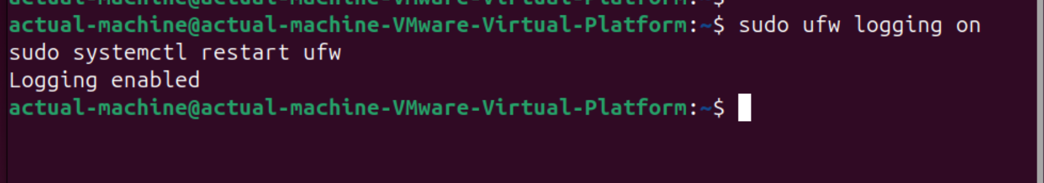

Verify Rules - **sudo ufw status verbose**

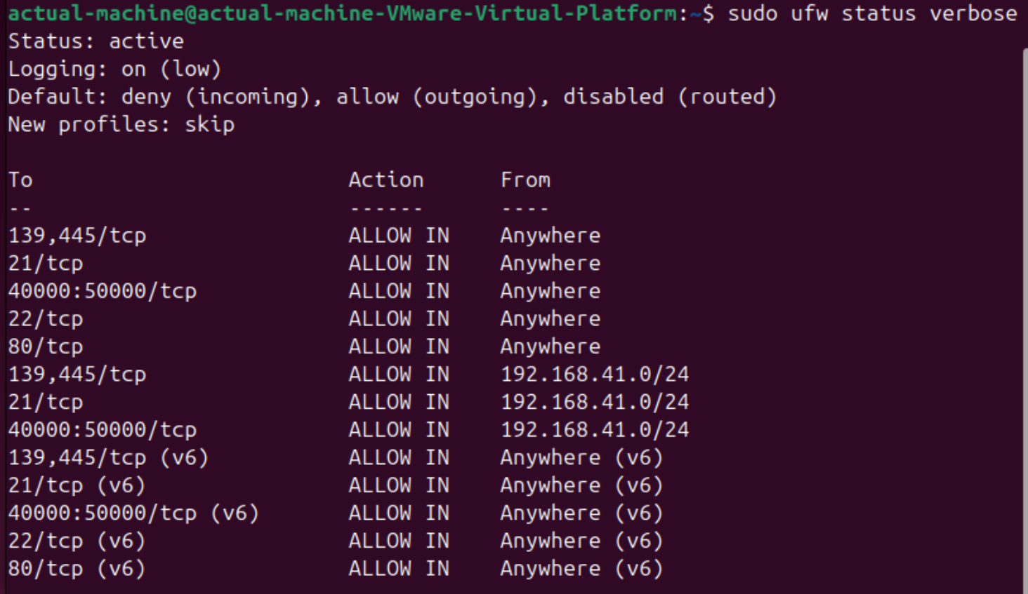

Now we will set the rules on **Honeypot Machine (Vulnerable Firewall)**

Allow All Incoming Traffic (Deliberately to make it Insecure)

**sudo ufw default allow incoming**

**sudo ufw default allow outgoing**

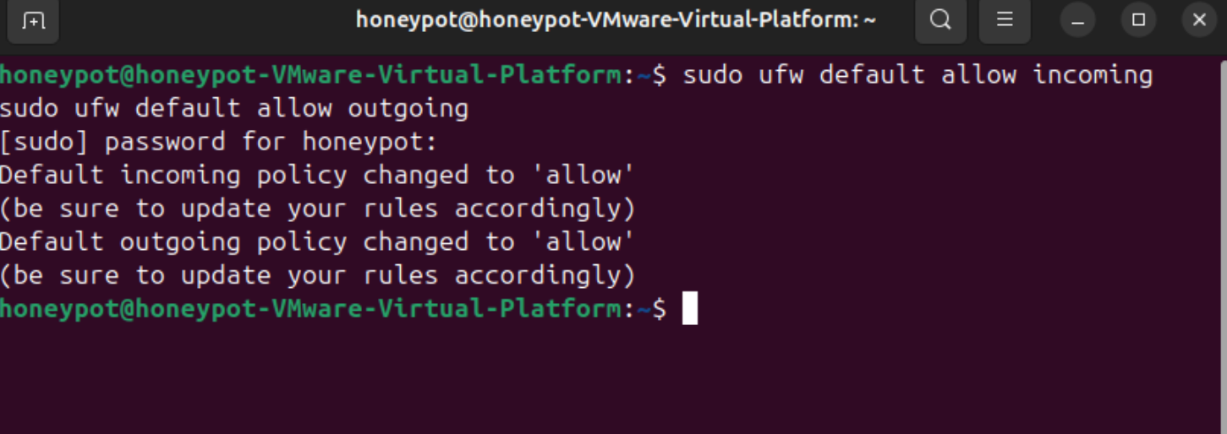

Open Ports for SMB and FTP with No Restrictions

**sudo ufw allow 21/tcp**

**sudo ufw allow 139,445/tcp**

**sudo ufw allow 40000:50000/tcp #passive FTP ports**

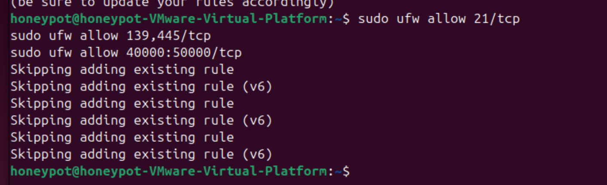

### Disable Logging (Avoid Detection by Attackers)

**sudo ufw logging off**

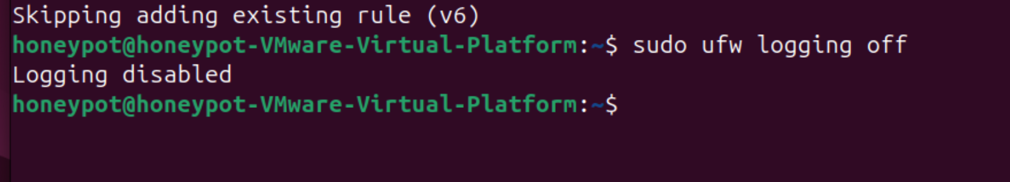

Restart Firewall - **sudo systemctl restart ufw**

& Check the firewall rules (we need to reboot the system sometime)- **sudo ufw status verbose**

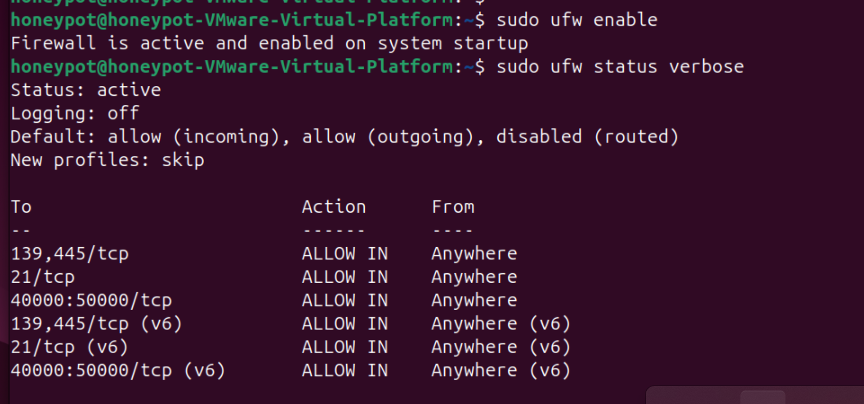

Now we will setup Wazuh server on Actual VM

We’ll refer the documentation for the quick installation - <https://documentation.wazuh.com/current/quickstart.html>

**sudo apt install curl apt-transport-https unzip -y**

**curl -** A tool for transferring data from URLs.

**apt-transport-https** – Allows APT to use HTTPS repositories.

**unzip** – Extracts .zip file

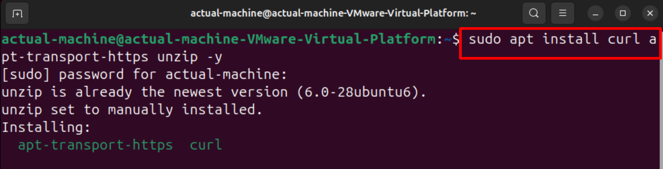

Install Wazuh Manager (Server) **-**

**curl -sO https://packages.wazuh.com/4.10/wazuh-install.sh**

**sudo bash wazuh-install.sh --wazuh-manager**

@@@@ **curl -sO https://packages.wazuh.com/4.10/wazuh-install.sh && sudo bash ./wazuh-install.sh -a**

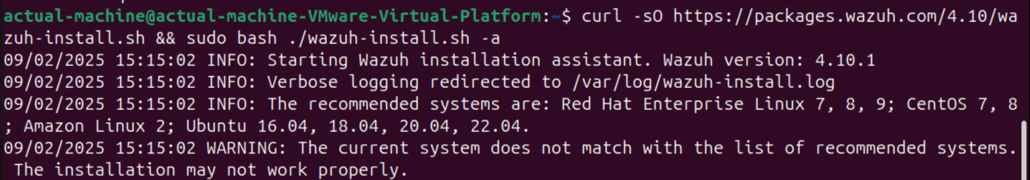

You need to do the following changes to Wazuh

Because while installing this shows the error message

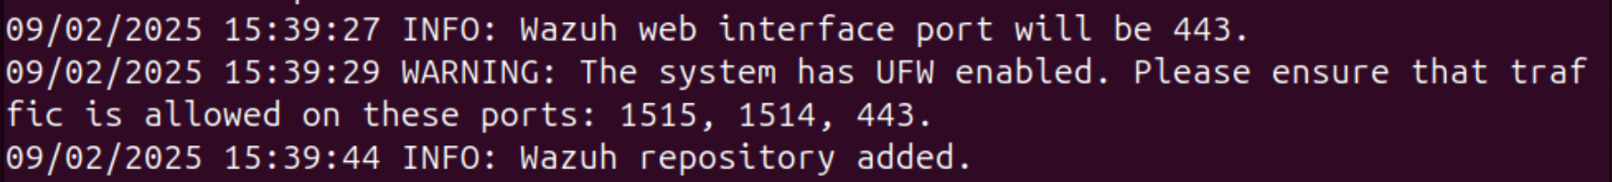

**sudo ufw allow 1515/tcp**

**sudo ufw allow 1514/tcp**

**sudo ufw allow 443/tcp**

**sudo systemctl restart**

**sudo ufw status verbose**

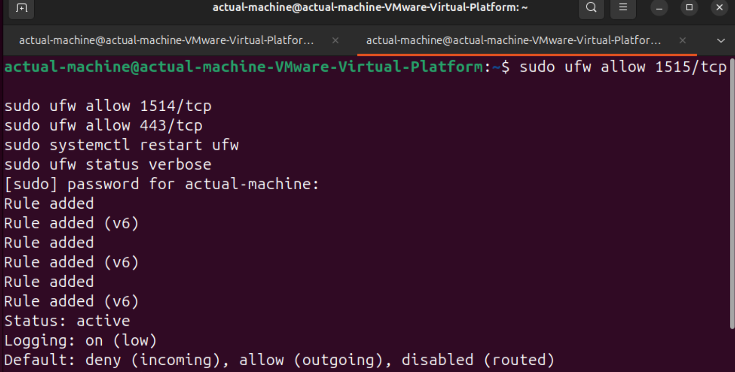

SElinix as IPS

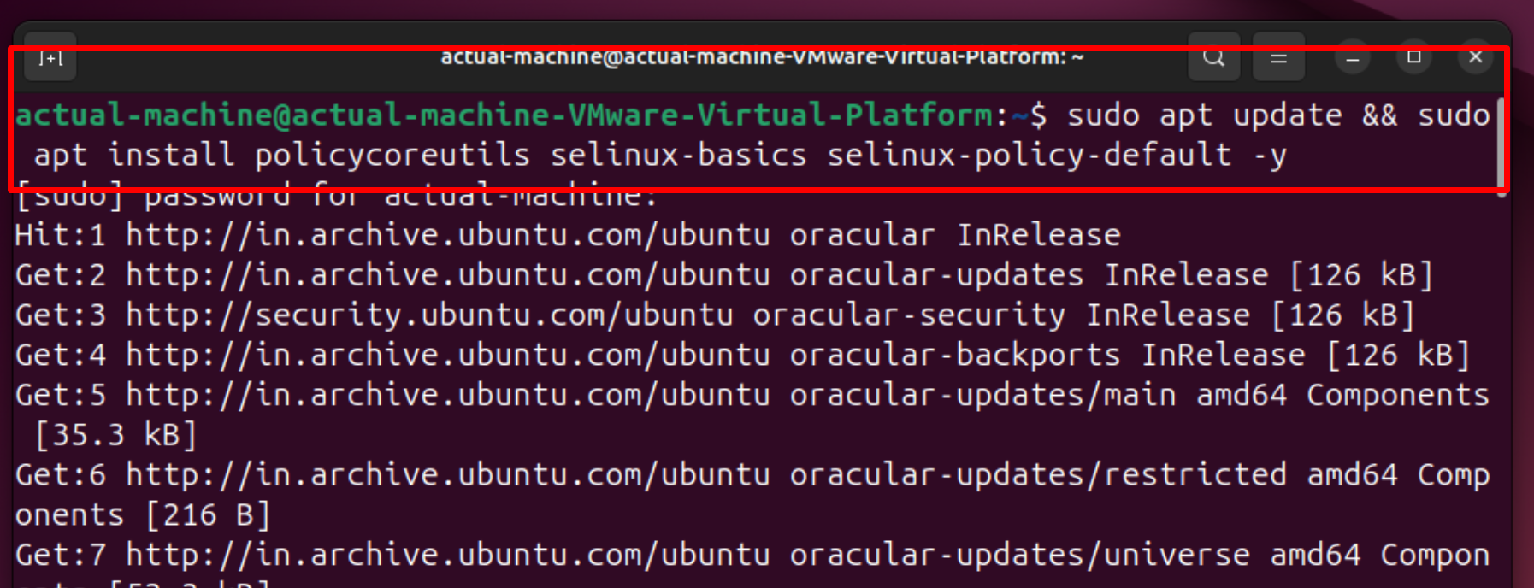

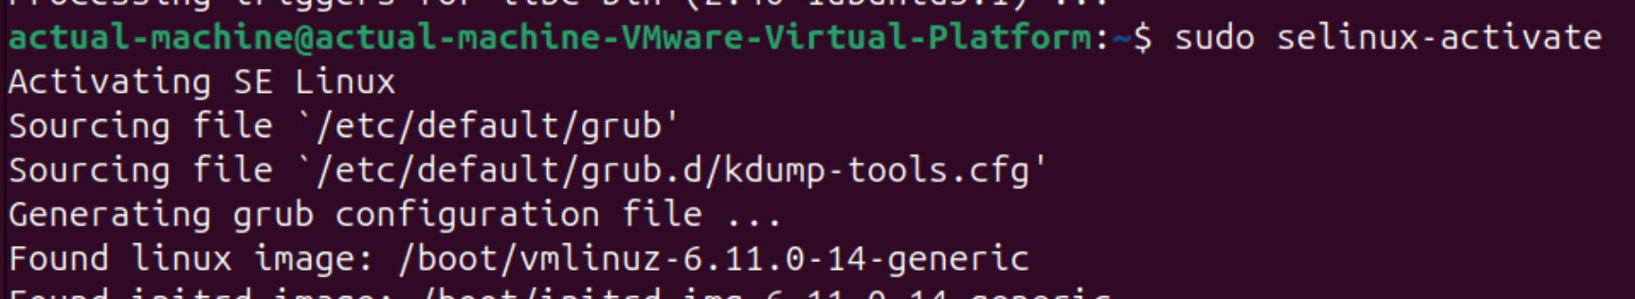

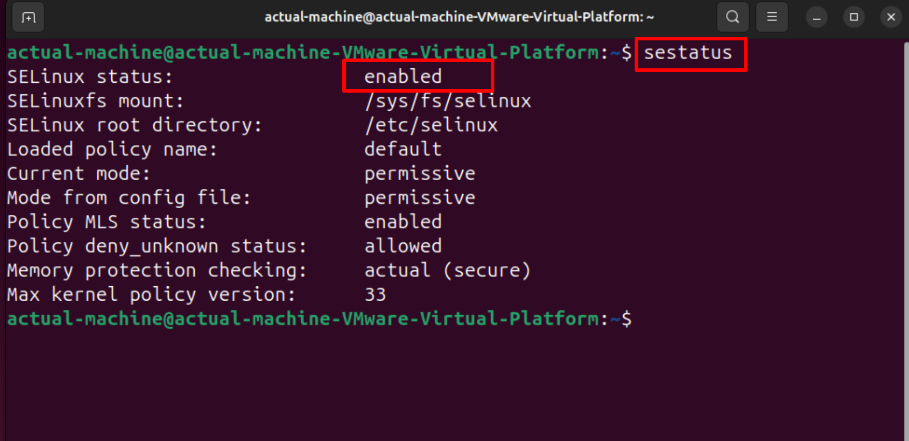

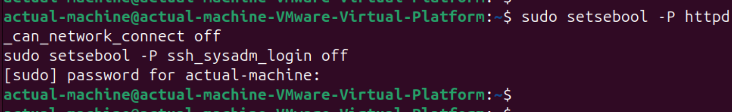

Install the website in both the VMs honeypot and actual machine

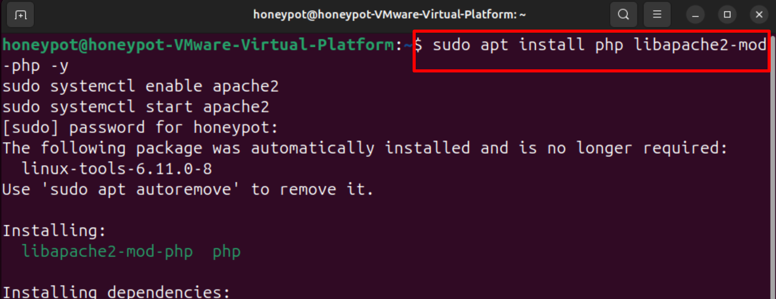

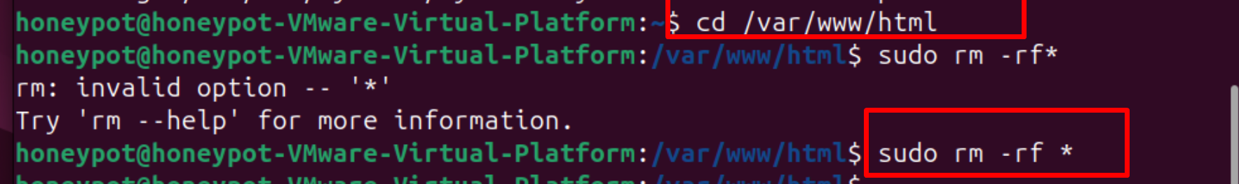

**Vulnerable website**

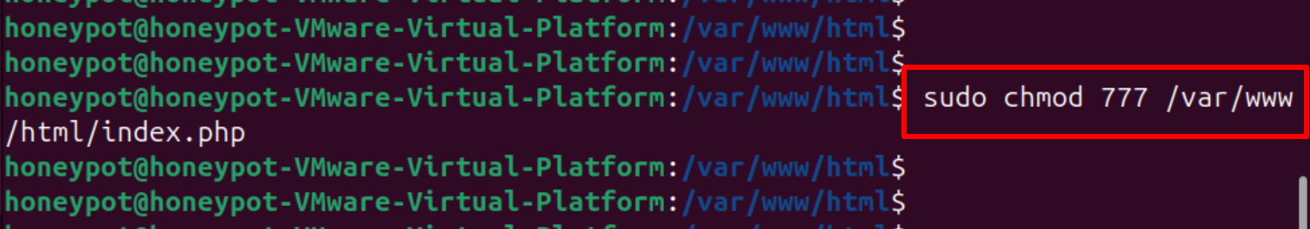

**Now we will create a secure php website on healthy VM**

And give the permission - **sudo chmod 644 /var/www/html/index.php**

**Now KALI attacker point of view**

Let’s do the ping scan and see how many hosts are up - **sduo nmap -sP 192.168.41.0/24**  
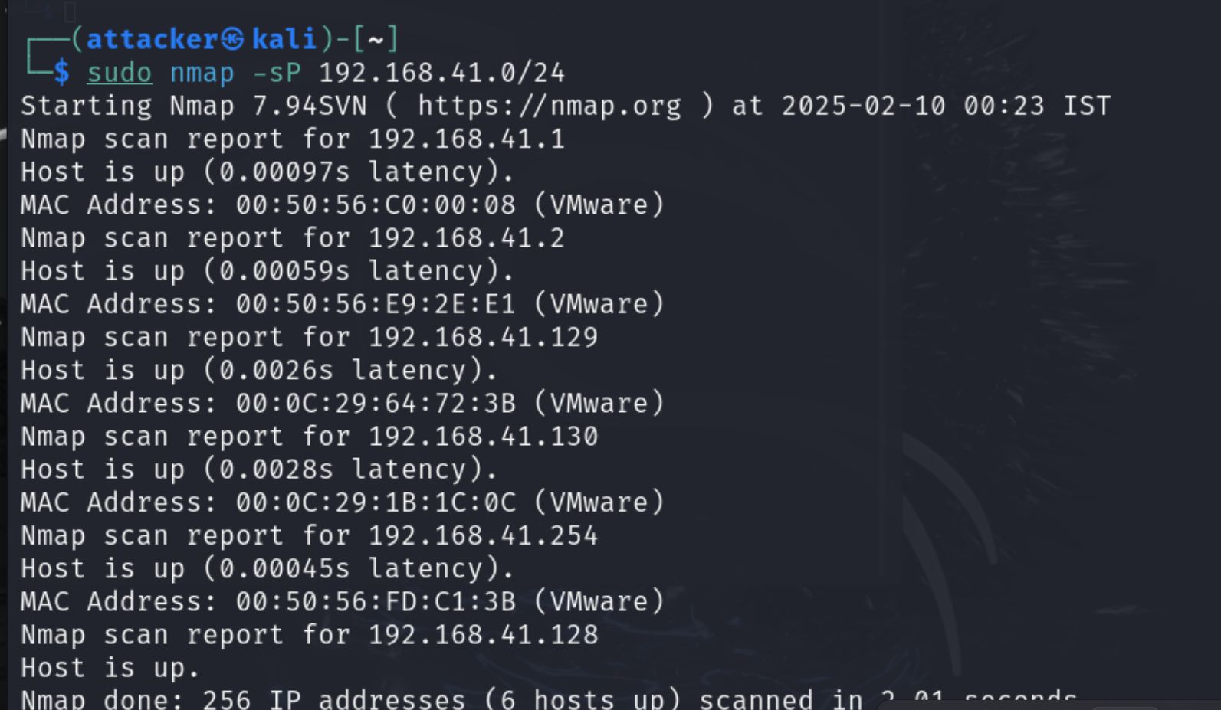

Now we now which hosts are up we will do the version info services that are running - **sudo nmap -sV 192.168.41.0/24**

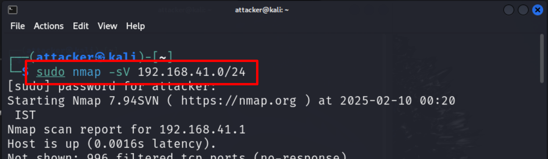

We can see 2 hosts having ports open is **192.168.41.129(honeypot)** and **192.168.41.130** actual healthy machine

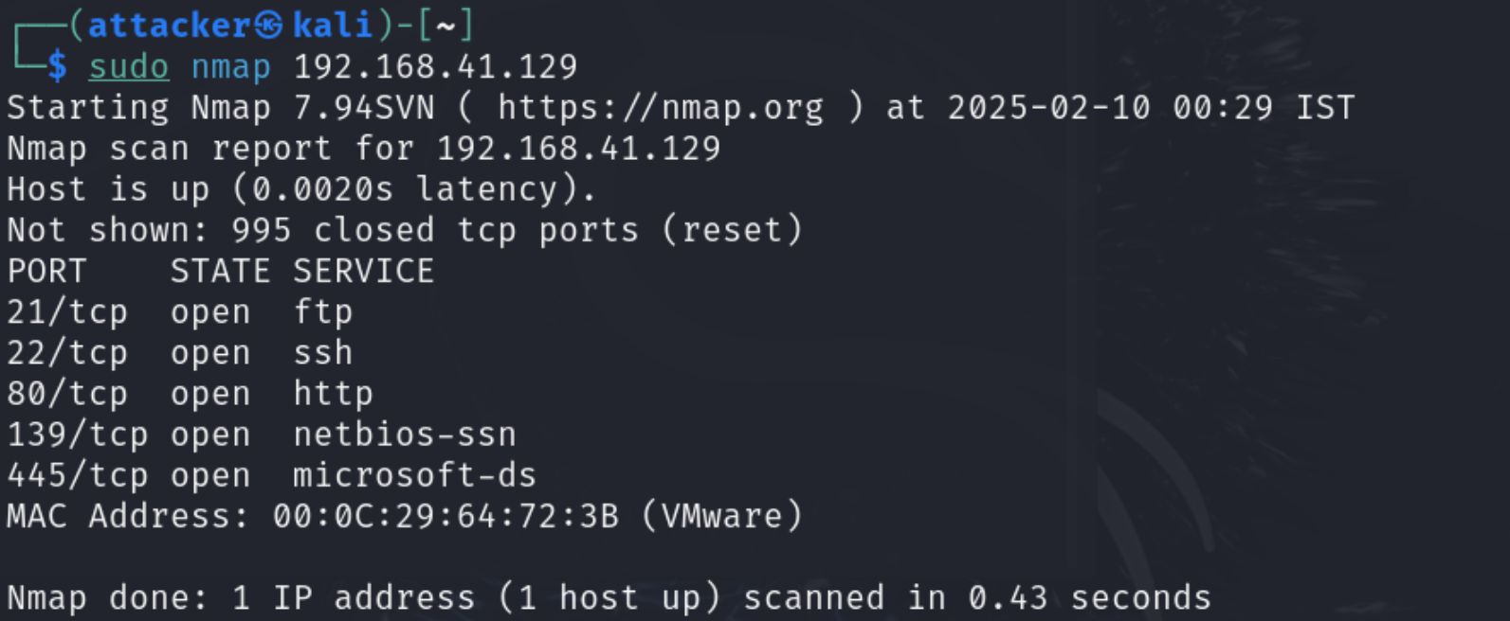

These are the services that you can see running on the honeypot machine

These services we can see running on the healthy machine

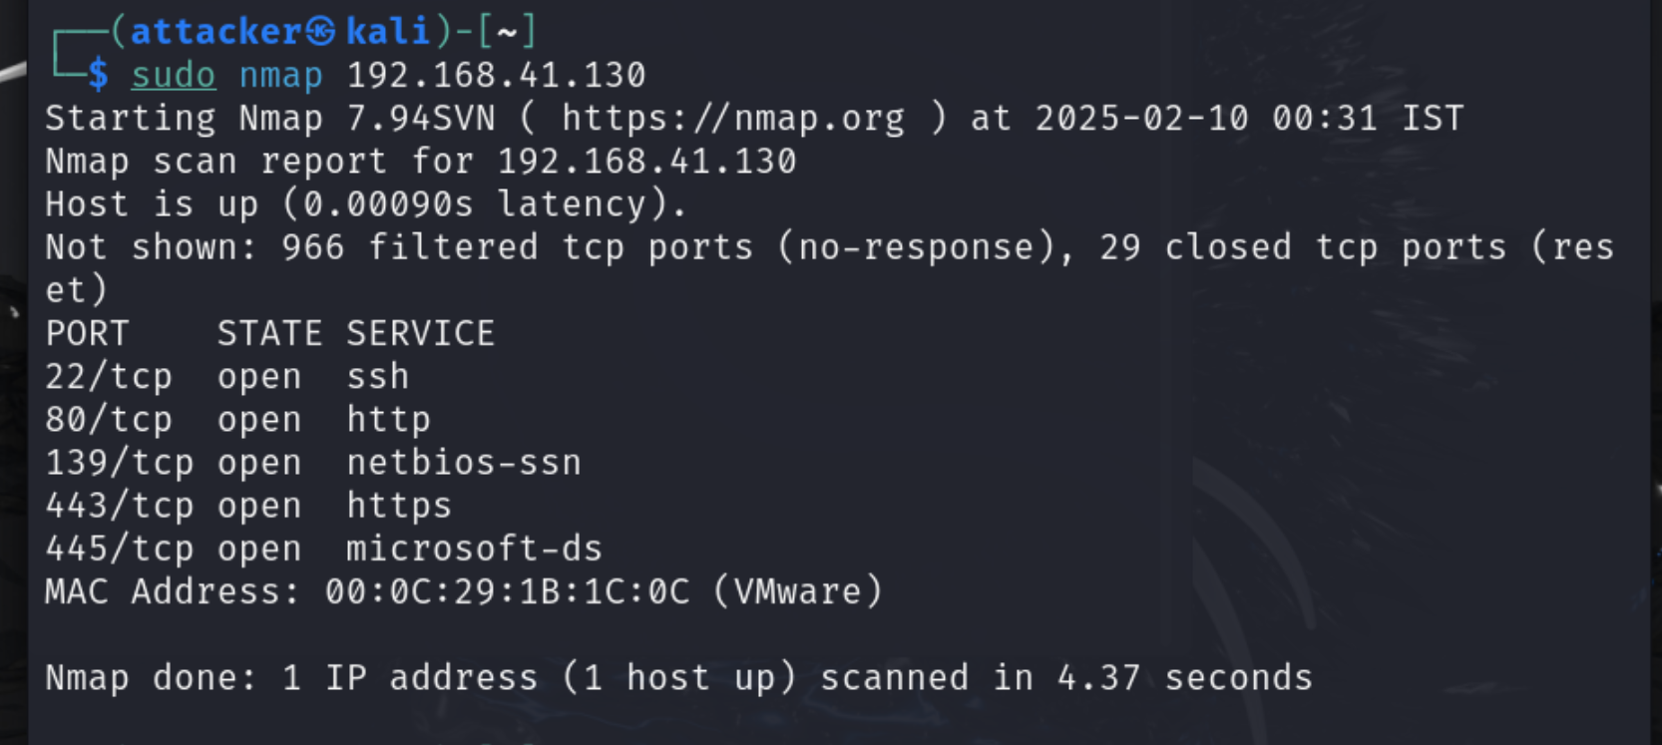

Here the attacker tries to get the ssh password - the most default password if **123**

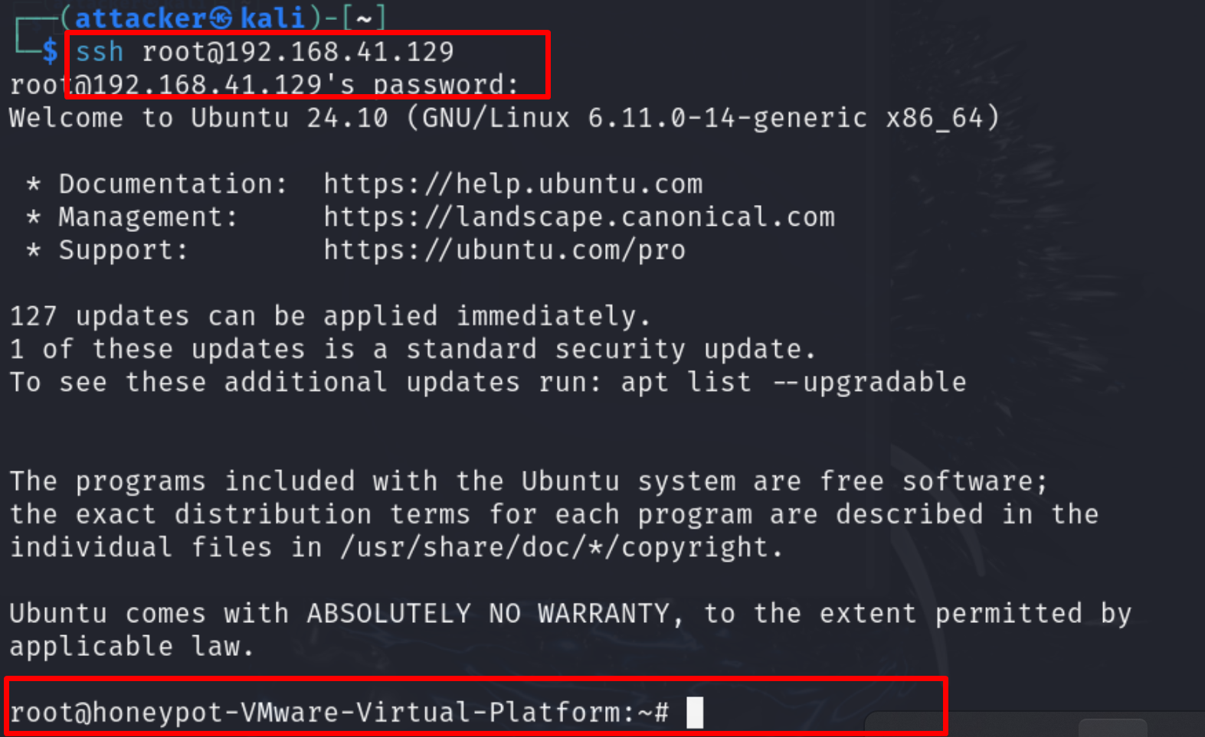

Hence the SSH login is **successful**

**Now on the healthy VM -**

The permission is **denied**  due to the firewall and configuration file 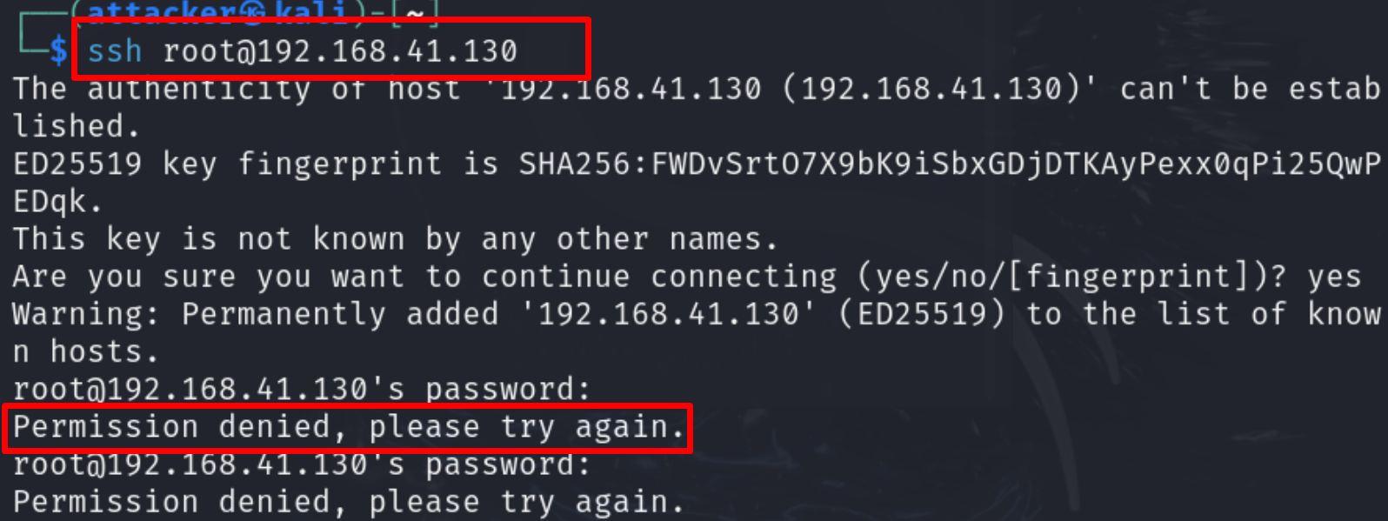

Now the attacker tries to attack the other services of the IP - **192.168.41.129** since that's a vulnerable one. Let’s perform the dictionary attack on the HTTP port 80

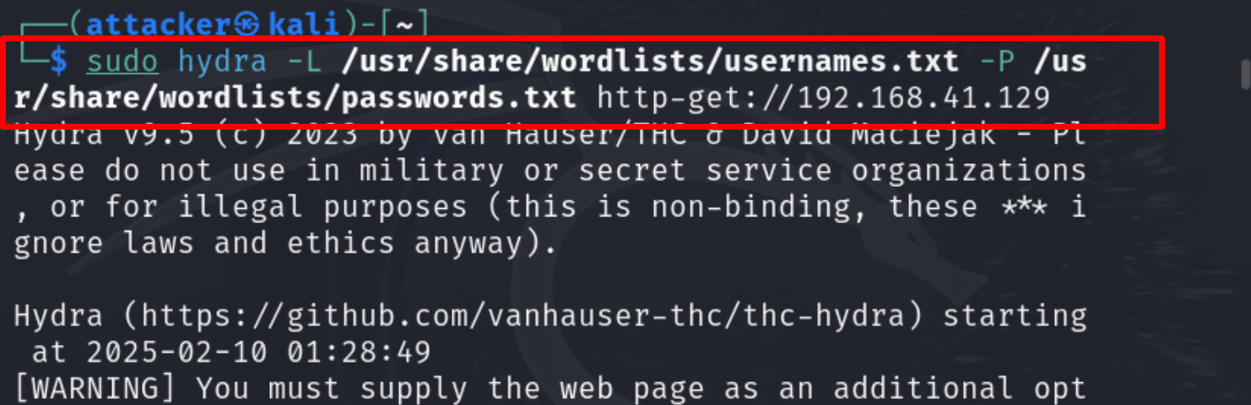

By doing this dictionary attack the attacker got username and passwords **256** valid passwords

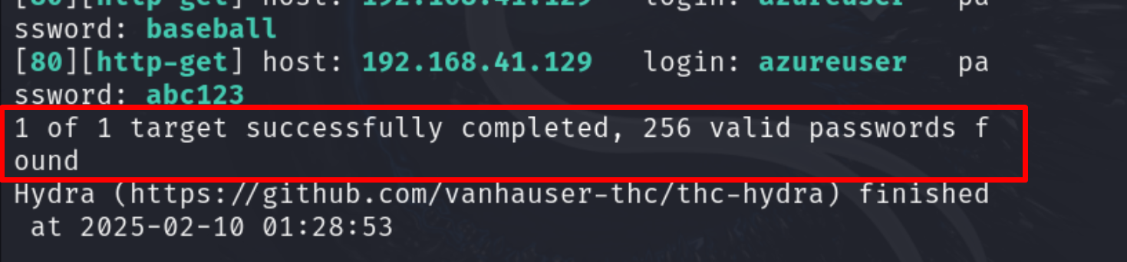

Now let’s try one of the username and password

Username - admin

Passwords - password

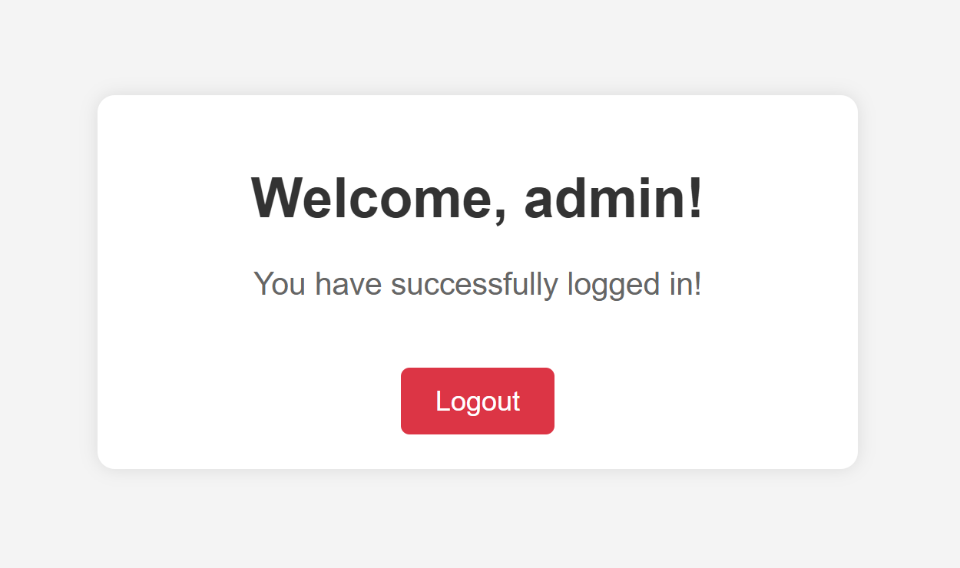

We get the message as login successful. Hence the dictionary attack is successful

Now we will try to perform SQL injection attack putting **' OR '1'='1' --**

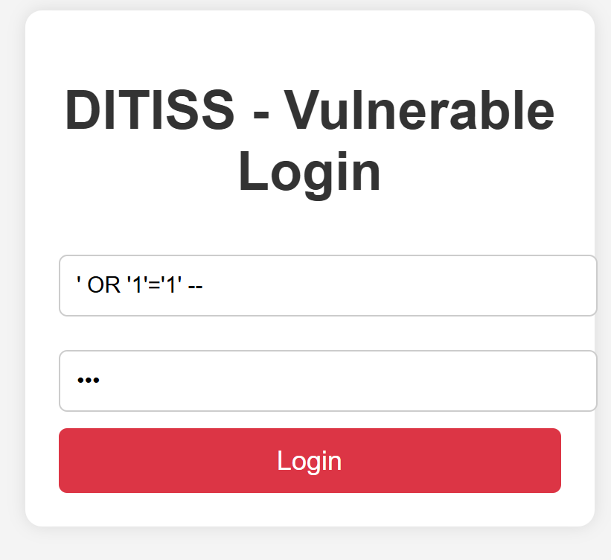

The login is successful leaving the password field blank

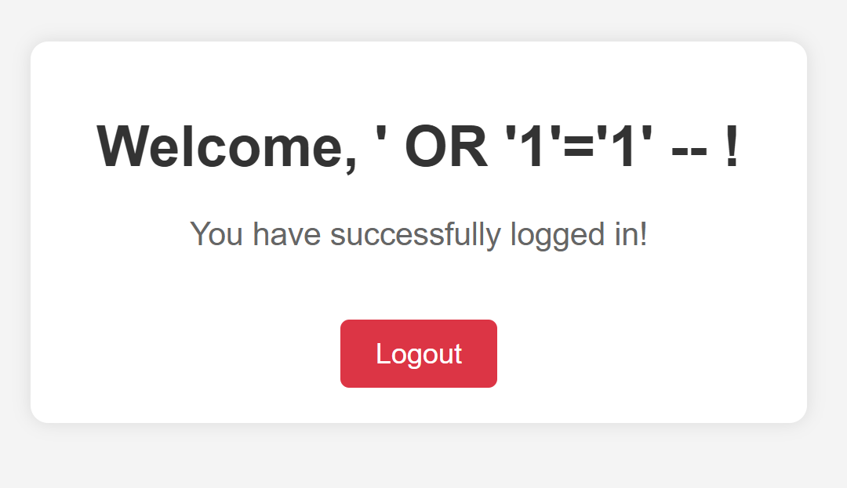

Let’s try to perform the DoS attack

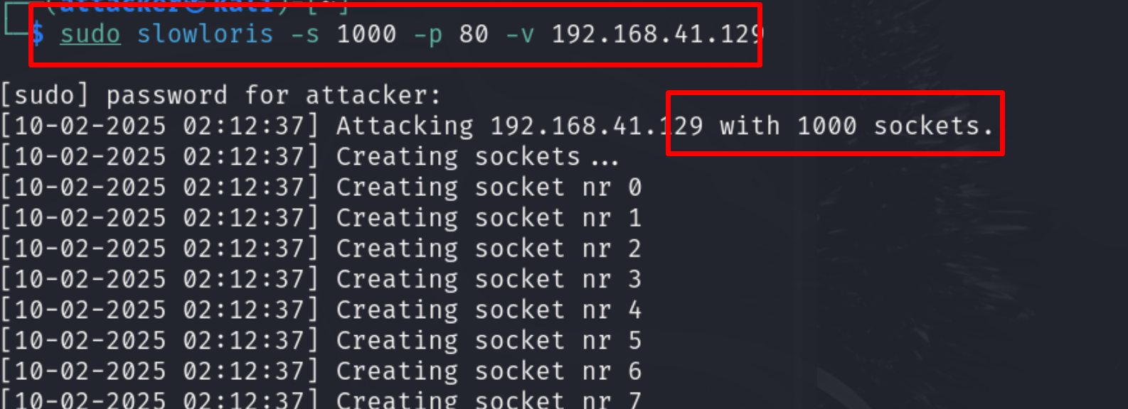

This attack will continue till 1000 counts keeping the website inaccessible for users



Attack on SMB open shares

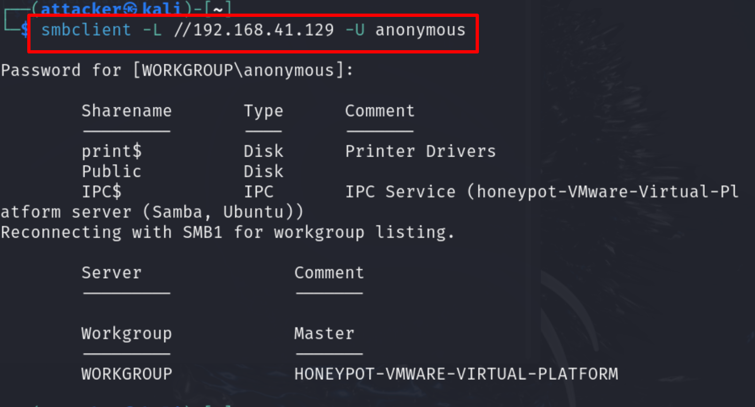

We can see different shared resources

Now we will check the FTP anonymous login

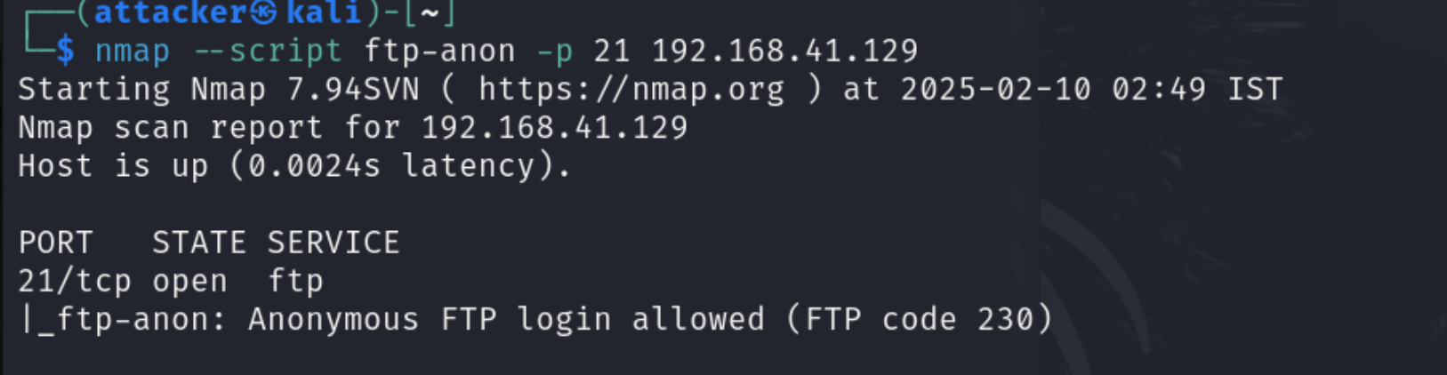

Let’s try to do it

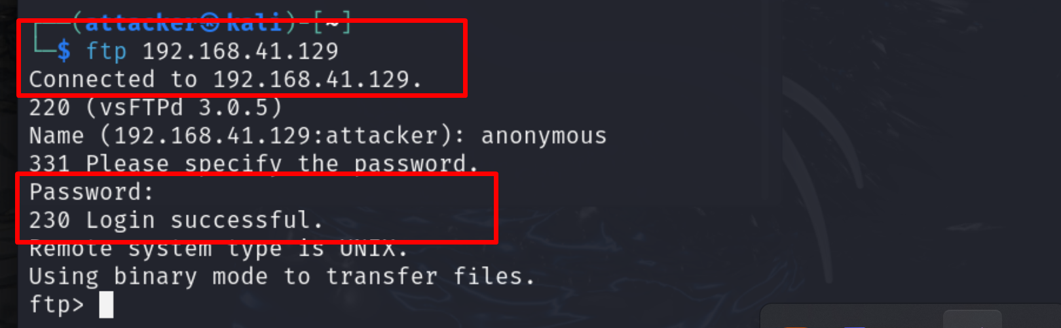

Here we can see it is **successful**

Now let’s check the **wazuh dashboard**

For the alerts

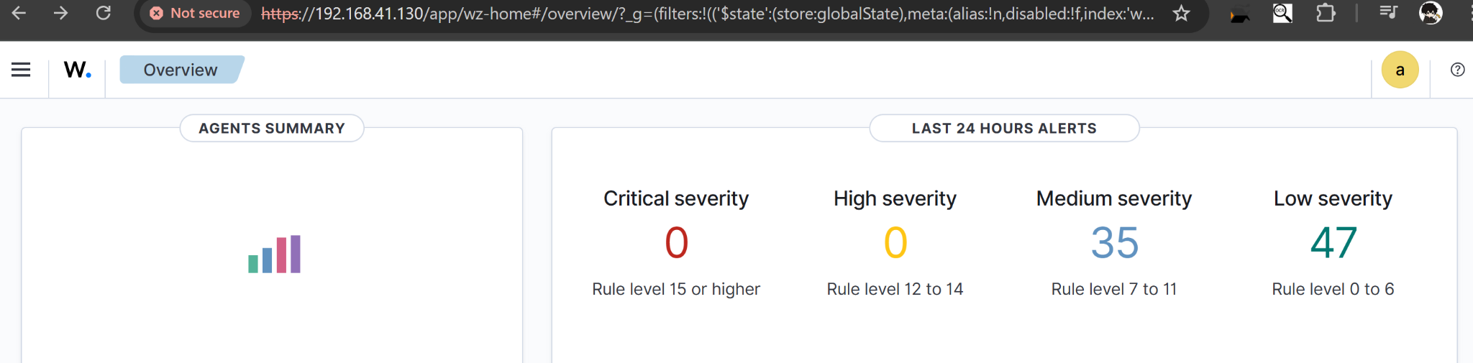

This shows the severity of the attacks that has been happening which is okay as compared to the Honeypot that we made